Computer Language Coding Concepts

Shadowing
A derived class can shadow a command of the base class. This means that when you call a base command through the derived object, the derived command is run instead.

Below you see a normal base member and a call to it:

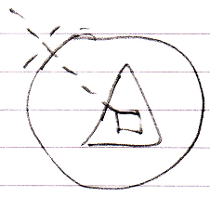

Below you see the situation when the base command is shadowed:

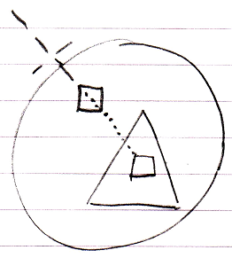

You can still call the base command, by qualifying the call so that the interface is adressed directly:

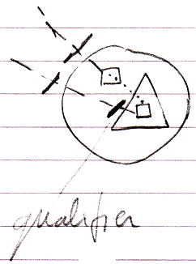

When the base class itself calls the shadowed command, the original base command is called.

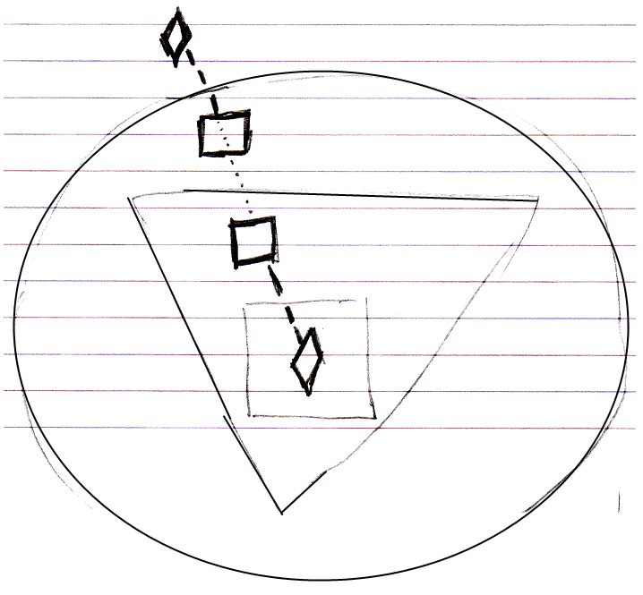

This is where the behavior of shadowing is different from overriding.

What should be mentioned is that you can also shadow objects, just like you can shadow commands.

Unshadowed:

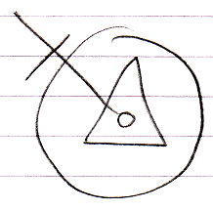

Shadowed:

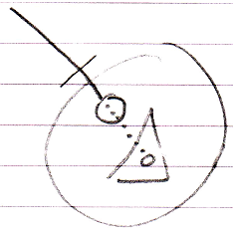

Access to base member through qualifier:

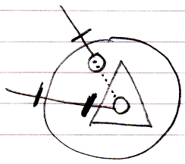

Base class calls base member, not derived member:

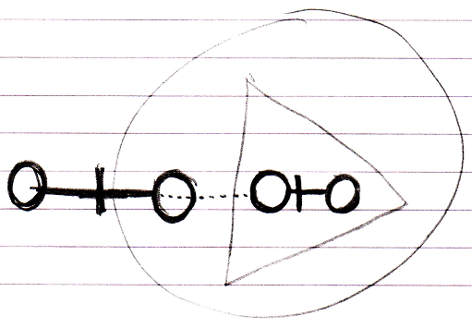

Author & Copyright: Jan-Joost van Zon Date: May 19, 2010 – July 12, 2010 Location: Oosterhout, The Netherlands Status: Finished

